CREATE DATABASE assignment;
USE assignment;

CREATE TABLE employees (
id INT PRIMARY KEY AUTO_INCREMENT COMMENT 'Unique Employee ID',
name VARCHAR(50) NOT NULL,
department VARCHAR(50) NOT NULL,
salary DECIMAL(10, 2) NOT NULL,
join_date DATE NOT NULL
) COMMENT='Stores employee details';

INSERT INTO employees (name, department, salary, join_date) VALUES
('John Doe', 'HR', 50000.00, '2024-01-15'),
('Jane Smith', 'IT', 60000.00, '2024-03-22'),
('Alice Johnson', 'Finance', 55000.00, '2024-07-30'),
('Bob Brown', 'IT', 62000.00, '2025-02-10'),
('Charlie Davis', 'HR', 48000.00, '2025-05-05');

ALTER TABLE employees MODIFY salary DECIMAL(10, 2) COMMENT "Employee's monthly salary";

DESC employees;

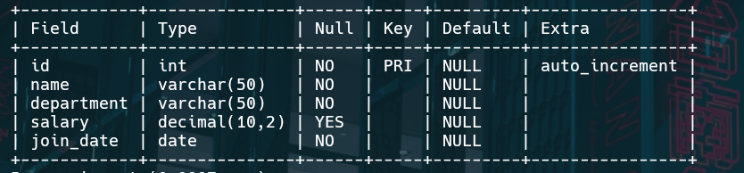

SHOW CREATE TABLE employees;

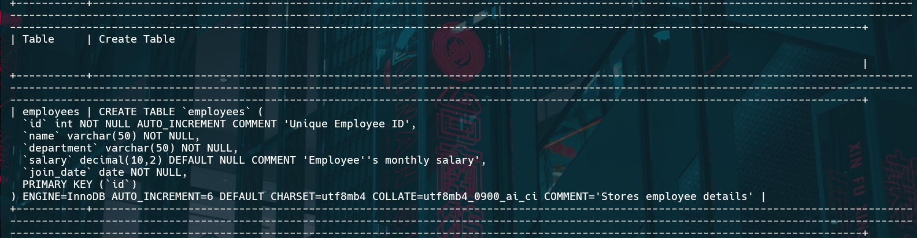

SELECT * FROM employees;

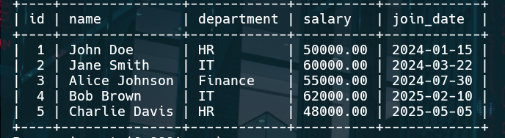

SELECT DISTINCT department FROM employees;

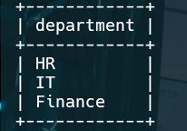

SELECT * FROM employees WHERE department='IT';

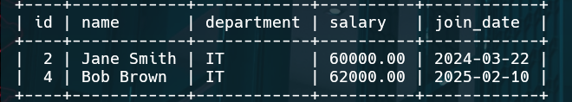

ALTER TABLE employees ADD COLUMN email VARCHAR(100);

SELECT * FROM employees LIMIT 3;

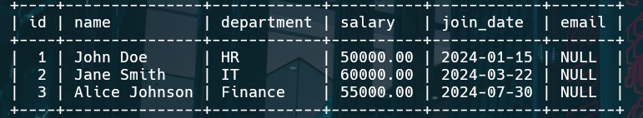

SELECT name AS 'Employee Name', salary AS 'Monthly Salary' FROM employees;

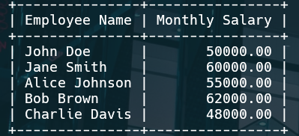

INSERT INTO employees (name, department, salary, join_date) VALUES ('Eva Green', 'Finance', 58000.00, '2025-01-10');

SELECT * FROM employees;

